KINESIS

3 Types: *Kinesis Streams, Kinesis Firehose, Kinesis Analytics*

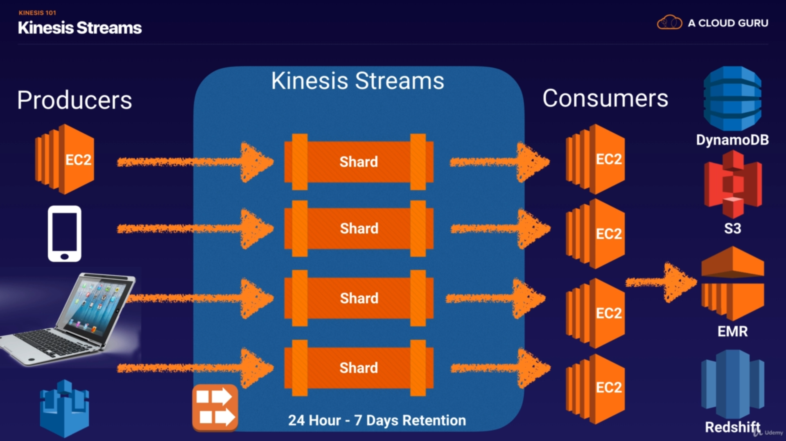

Only Kinesis streams has Shards.

No persistent storage in **Kinesis Firehose**. Can have Lambda functions inside

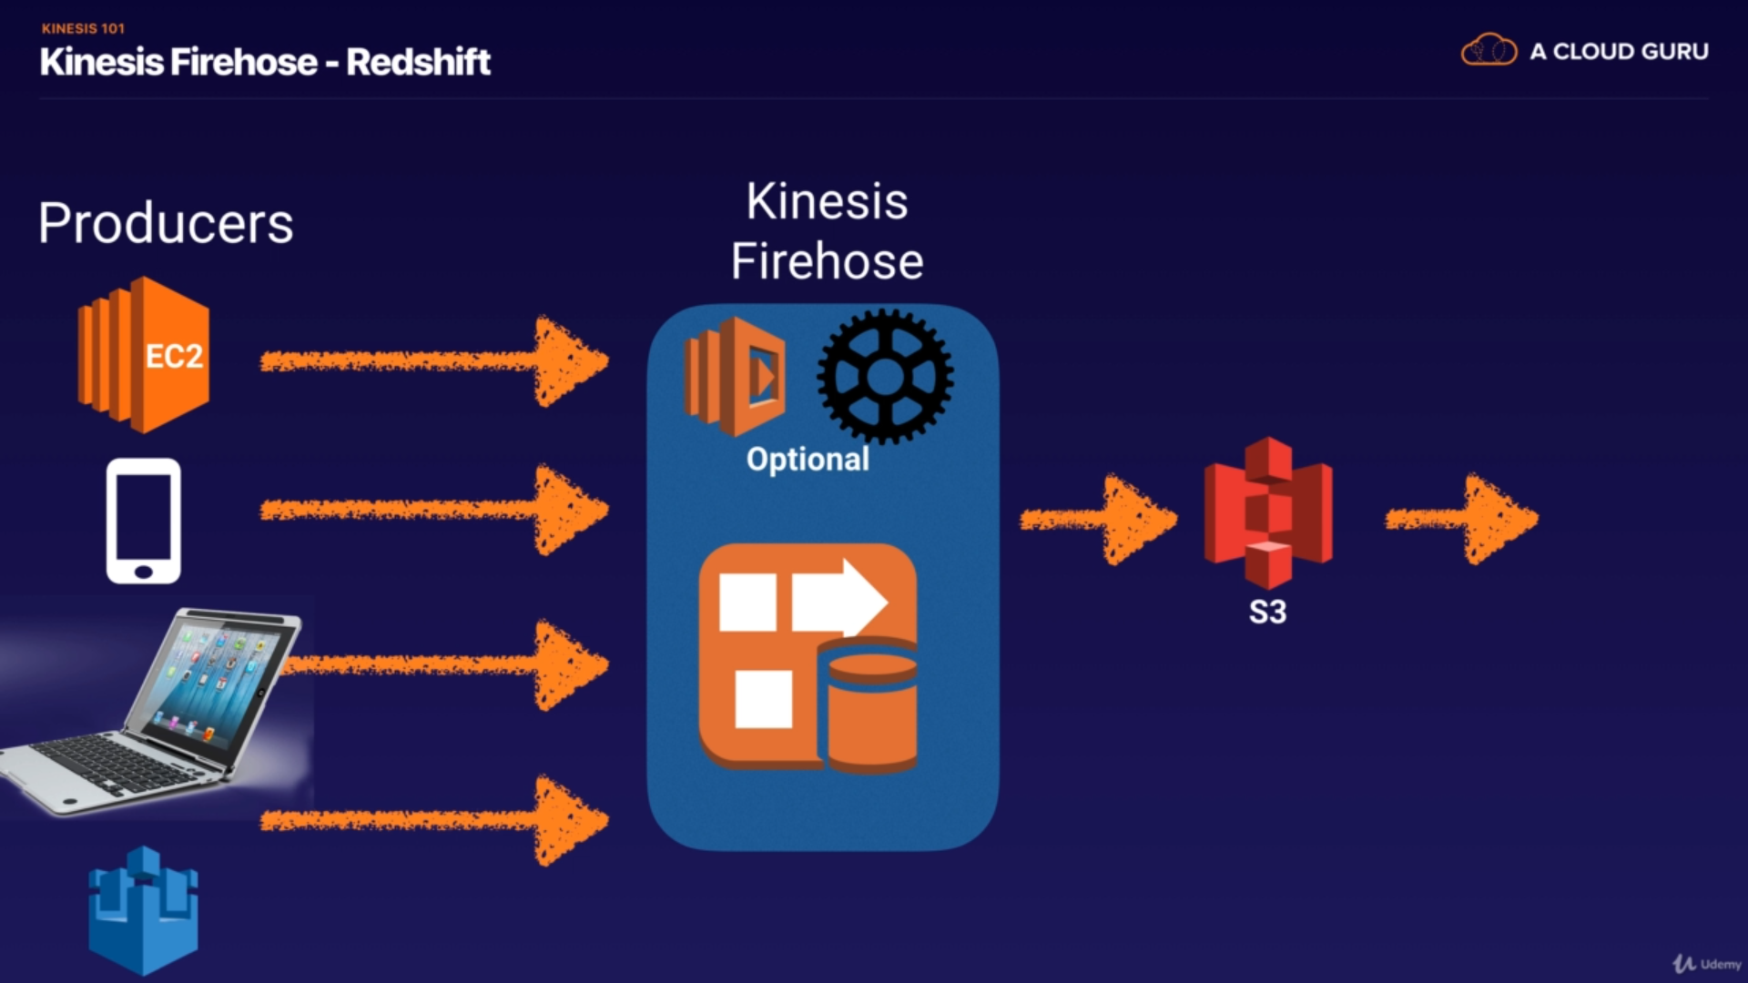

Kinesis Analytics works with Stream and Firehose.

